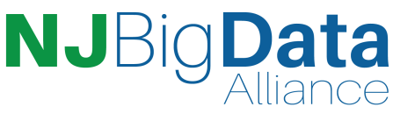
Invitation to …
The New Jersey Big Data Alliance
Research Forum

When: Friday December 10, 2021 9:00 am–12:00 pm ET

Where: Virtual Event - Please Register here: https://bit.ly/NJBDA2021ResearchForum

The New Jersey Big Data Alliance is convening NJBDA Research Forum which is open to all research professionals, faculty, research computing professionals, students, and other campus partners interested in shaping the Big Data research collaboration landscape. Please feel free to share with your communities!

Forum Highlights

- Big Data Research Collaborations

- Communities and Resources for Advancing Collaborations

- Funding Opportunities

- Establish Contacts with the New Jersey Big Data Research Community

Join us for this unique opportunity to connect to the Big Data Research Community!

For additional information contact: research@njedge.net
To learn more about the New Jersey Big Data Alliance visit: https://njbda.org

Register here for the NJBDA Research Forum December 10 9:00 AM!

